**DATABASE MANAGEMENT**

Databases allows

* Users to store,
* organise and search data,
* Outputting it in either a printed or electronic format.

Databases have many uses,

* Storing school or college students’ academic record.
* Cataloguing and managing stock in shops,
* Organising a collection of books, films and music.

Databases are used in

* Banking
* Police and crime information systems
* Vehicle registration systems.

Many organisations also uses databases when sending out letters and emails to customers.

When data is stored in a database, **it must be stored as a specific type of data**. This makes sure that **appropriate operations** can be carried out on the data at later date.

* Data types
  + Alphanumeric / text
    - 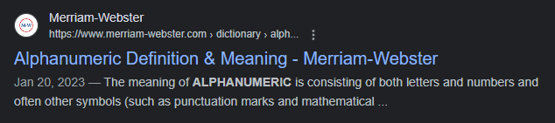
      * Password-1234-4
  + Numeric / number
    - Eg. 1,2,3,4
  + Date
    - Eg. 26/12/2013
  + Currency
    - $ 5.99
  + Logical / Boolean
    - Came from George Boole in 19th century.
    - True or False
      * 13>50= False
      * 13 < 50 = True
      * *AND OR NOT*
      * 12>50 *AND* 13>50
      * *NOT* False *AND* TRUE
      * 5+1 >= 6 *OR* 5+6 <= 56

Database Structure

A database consists of one or more tables.



A database with only one table is called **Flat file database**. 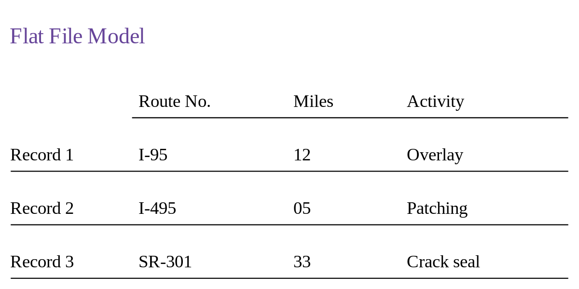

A database with more than one table is known as a **Relational Database**.

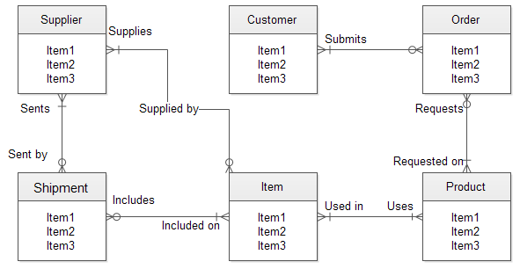

Entity

Entity in a database, something that exists as a single and complete unit. 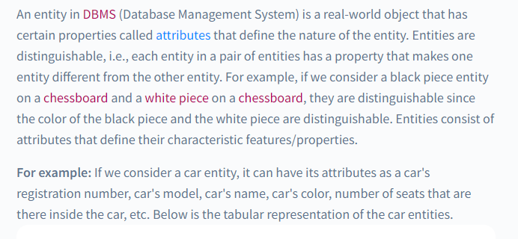

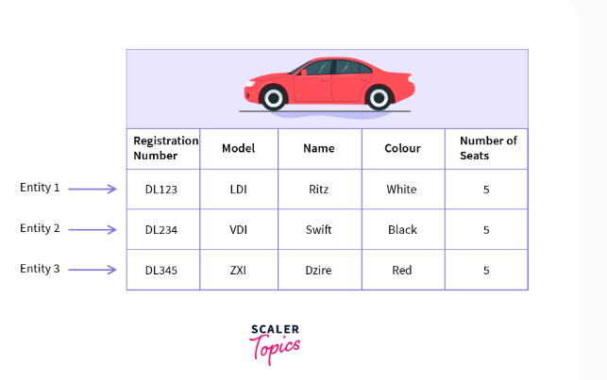



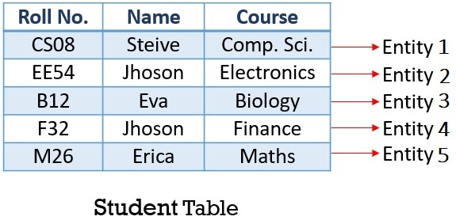

Attribute

Attribute in a database a characteristic feature, or quality of an entity.

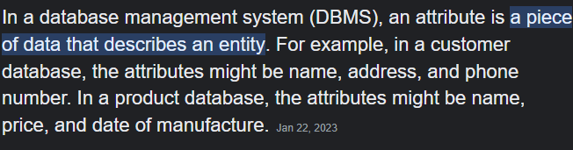

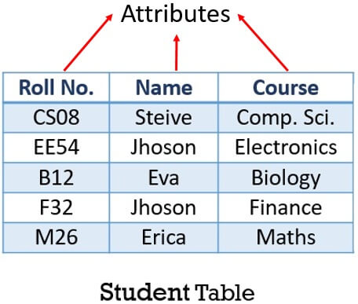

In DBMS, we have entities, and each entity contains some property about their behavior /

A characteristic or property of an entity

which is also called the attribute.

A entity is called row.

Rows/entities called Records.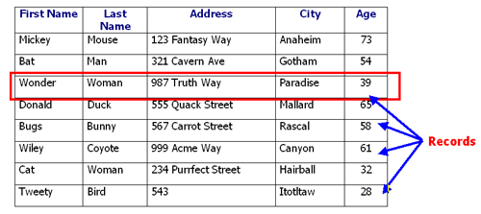

A attribute is called column.

Columns/ attributes is called Fields.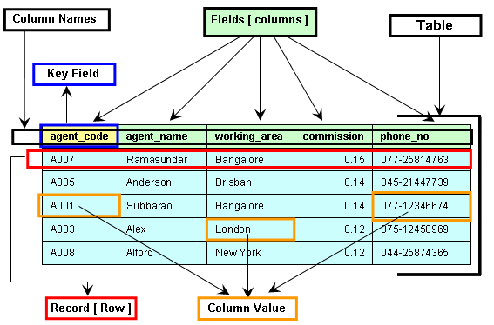

Primary Key.

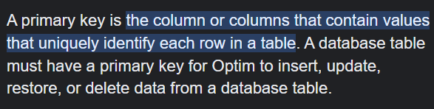

Primary key field.

Primary key field in a db, the field that holds the primary key, which is a unique attribute stored for each entity.

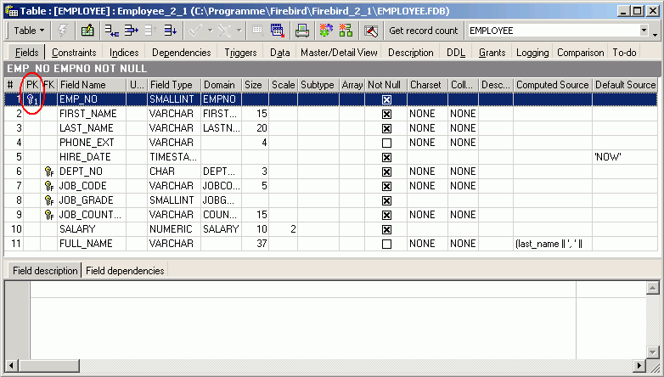

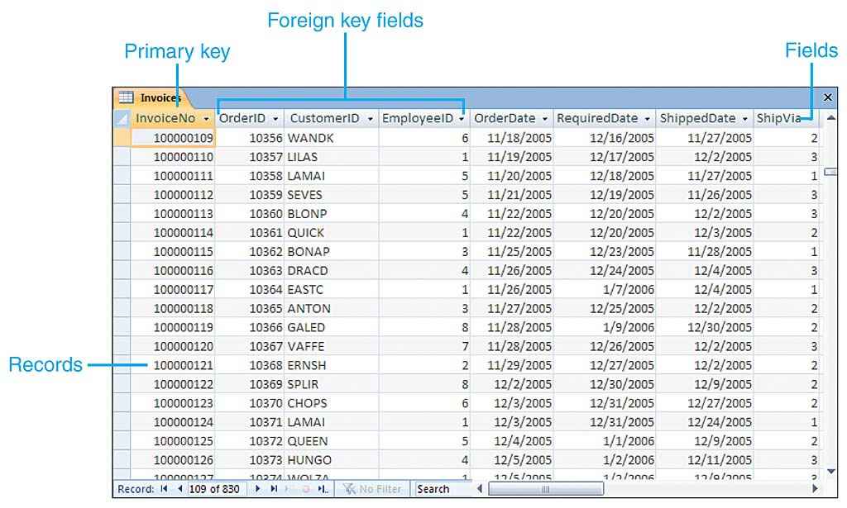

Referential integrity

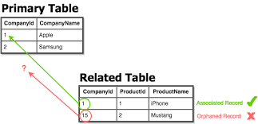

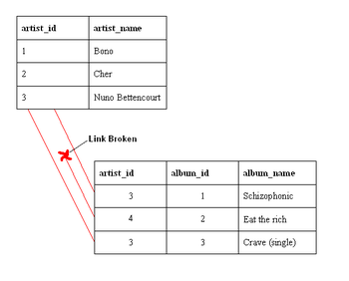

Referential integrity the state of a database when any foreign key field in a table refers to a primary key in a related table.

When you enforce referential integrity, the database will only allow data to be entered if the related record exists.